Co-Chairs

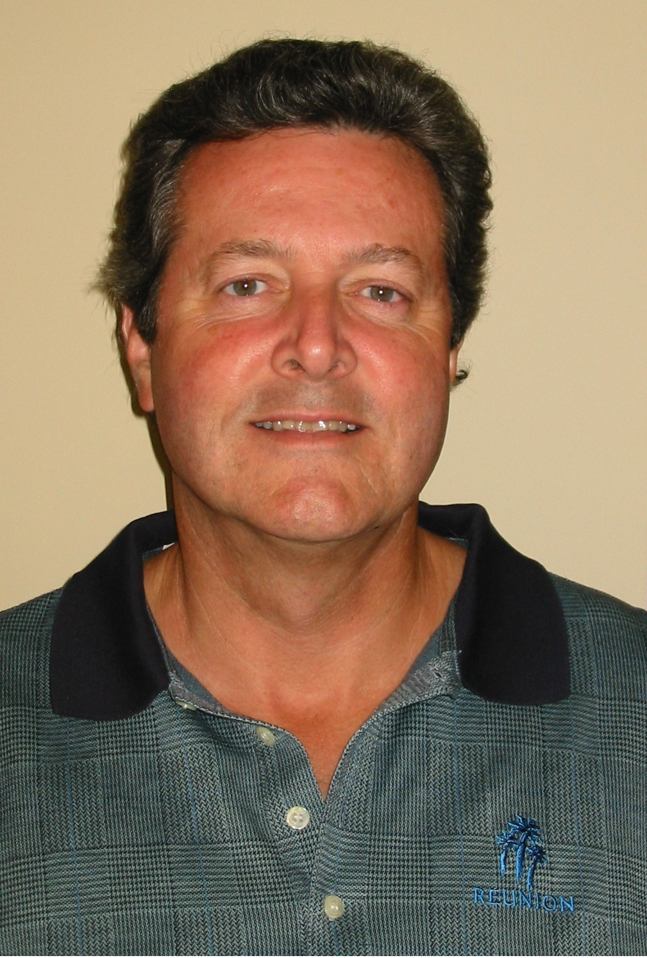
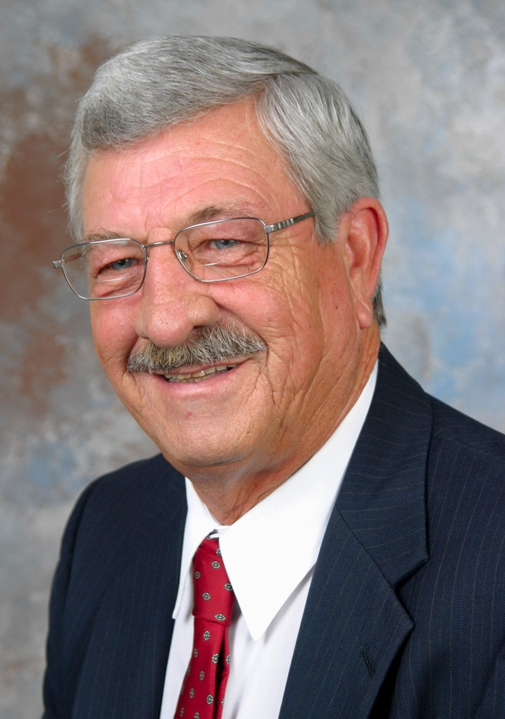

Bob DeVore
Lowe Destination Development
Bobby Masters
The Ginn Company

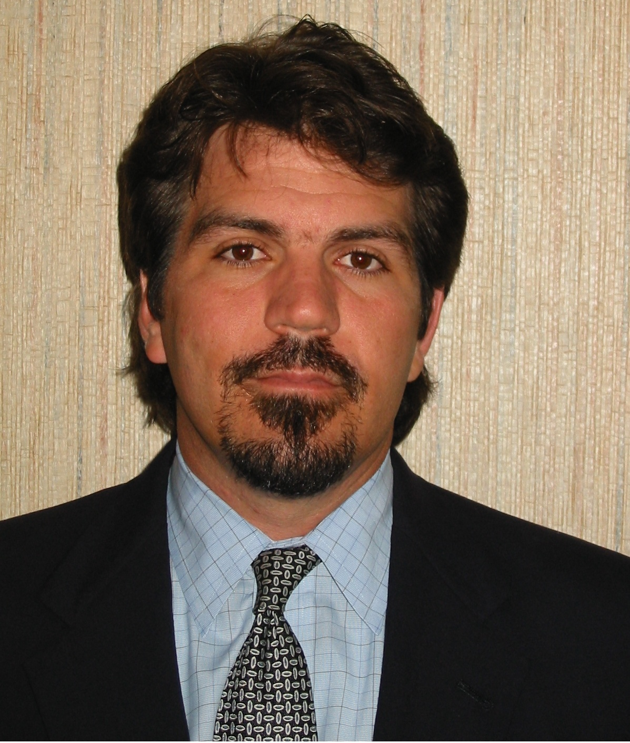
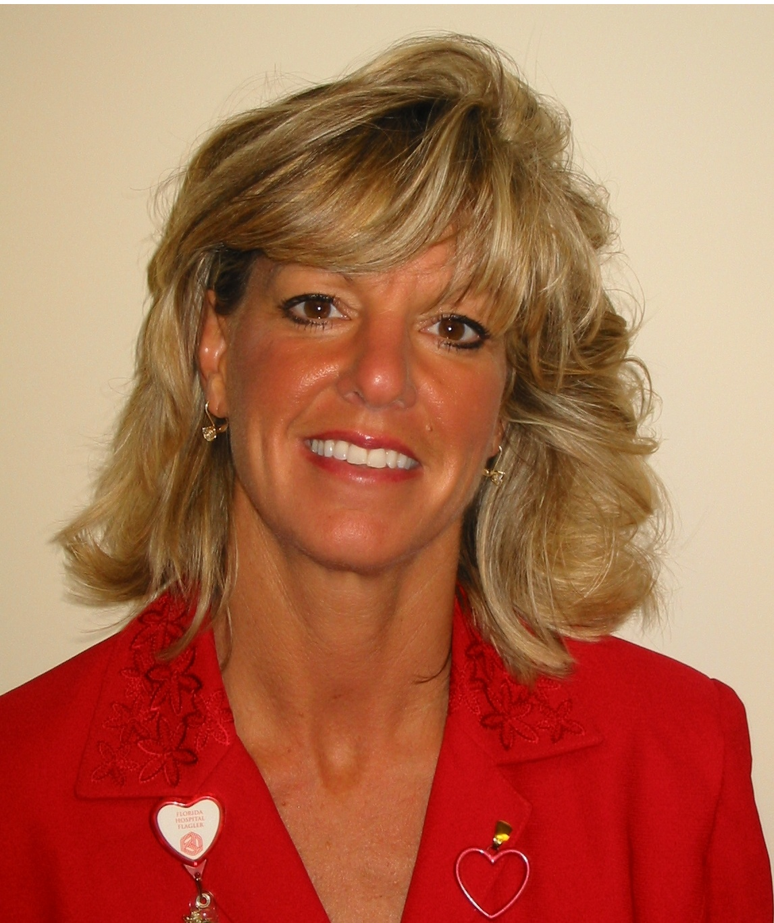
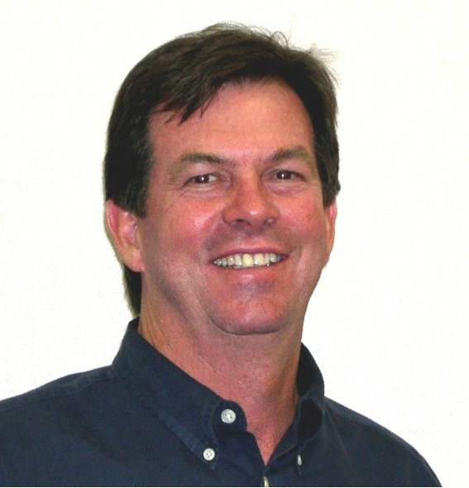

David Lusby
Palm Coast Holdings
Michael Chiumento III
Chiumento & Associates, P.A.
Tammy Daniel
Florida Hospital - Flagler

Campaign Advisory Council

Art Barr
DevNet Services

Steven Burley
Daytona Beach Community College

Sam Cline
S. E. Cline Construction

Jim Cullis
LandMar Group, LLC

Andy Dance
Ghyabi & Associates

Bill Delbrugge
Flagler County Public Schools

Rick Fraser
Workforce Development Board of Flagler and Volusia Counties

Mick Guthberthson
City of Bunnell

Commissioner Blair Kanbar
Flagler County

Paul Katz
Katz & Green

Mike Kelley
Hayward Brown

Jerry Masiello
Watson Realty Corporation

Jane Mealy
City of Flagler Beach

Councilman Jon Netts
City of Palm Coast

Bruce Page
Cypress Coquina Bank

Barbara Revels
Coquina Real Estate & Construction

Dave Roberts
ACI

Lea Stokes
Preferred Management Services

